Celebration of the International Day of the Portuguese Language and Culture of the Community of Portuguese Speaking Countries

Tbilisi State University
May 3-5, 2017
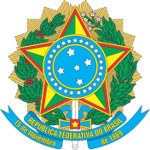
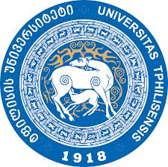
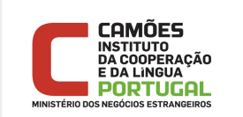

In May the Community of Portuguese Speaking Countries (CPLP) celebrates the International Day of Portuguese Language. Since Georgia obtained the status of Associate Observer of the CPLP in 2014, this year TSU – Camoes Portuguese Language Center and the Brazilian Embassy in Tbilisi will commemorate the date with cultural activities. The activities will take place during the period of 3-5 May at Ivane Javakhishvili Tbilisi State University.

Tuesday, 3rd May
Film Screening
“Que horas ela volta? ”/ “The Second Mother”, Anna Muylaert, 2015 (Brazil)
Portuguese with English Subtitles
19h, Building I, room 101
Introduction by Mr. Marcus Marinho, Deputy Head of Mission at Brazilian Embassy in Tbilisi,
Mari Lomsadze, Student of Portuguese Language at TSU

Wednesday, 4th May
Conference TSU Event Hall, Building I

- 17h30 Opening Speech by Director of TSU Camões Portuguese Language Center,
Mrs. Isabel Gaspar

- Conferences for a Joint Vision of Aspects of Lusophony and its Current and Potential Relationship with Georgia
  - TSU Rector, Mr. George Sharvashidze
  - Director of International Cultural and Humanitarian Relations,
Ministry of Foreign Affairs of Georgia, Mrs. Ketevan Kandelaki
  - Brazilian Ambassador in Tbilisi, Mr. Cícero Garcia
  - Honorary Consul of Portugal in Georgia, Mr. Kakha Sharabidze

- Piano Recital by Mrs. Maria de los Angeles Iglesias
  - Villa-Lobos - Impressões Seresteiras
  - Francisco Mignoni - Valsa de Esquina nº 1
  - Camargo Guarnieri - Ponteio nº 49 em dó menor

- Best Student Award of Portuguese Language: A Short Vision of Studies Experiences in Portugal, Natia Bregvadze and Ani Gurulishvili

- Presentation of Erasmus Mundus Students General Program in Portugal
Nata Kurkhuli and Beka Khutsishvili

Buffet

Thursday, 5th May
Film Screening
“Batuque, a alma de um povo”/“Creole Batuko”, Júlio Silvão Tavares, 2007 (Cape Verde)
Portuguese with English Subtitles
19h, Building I, room 101
Introduction by Mrs. Isabel Gaspar, Director of TSU Camões Portuguese Language Center,
Nata Kurkhuli, Student of Portuguese Language at TSU

ALL THE EVENTS ARE IN ENGLISH
ENTRANCE IS FREE

